Reset Content Descriptor(RCD) Node

* Here in this example MQ input receives an XML input.
* However, The parse is left out unselected(for the MQ input) and by default it treats as BLOB.
* Subsequently, If we wish to re-parse it to a domain of our choice(here XMLNSC), We use the RCD node.
* In the RCD properties we need to choose our type of parse and click on the check-box 'Reset Message Domain'.
* The RCD will parses as per the settings and passes on the control after passing by forming a new message tree.

1. Click on File and select "New"=> "Application"

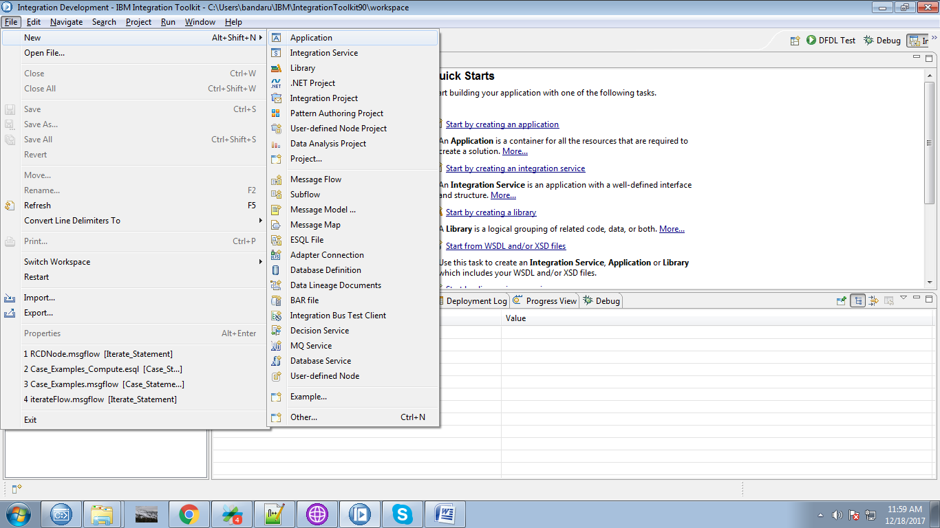

2. Name your application and click "Finish" button.

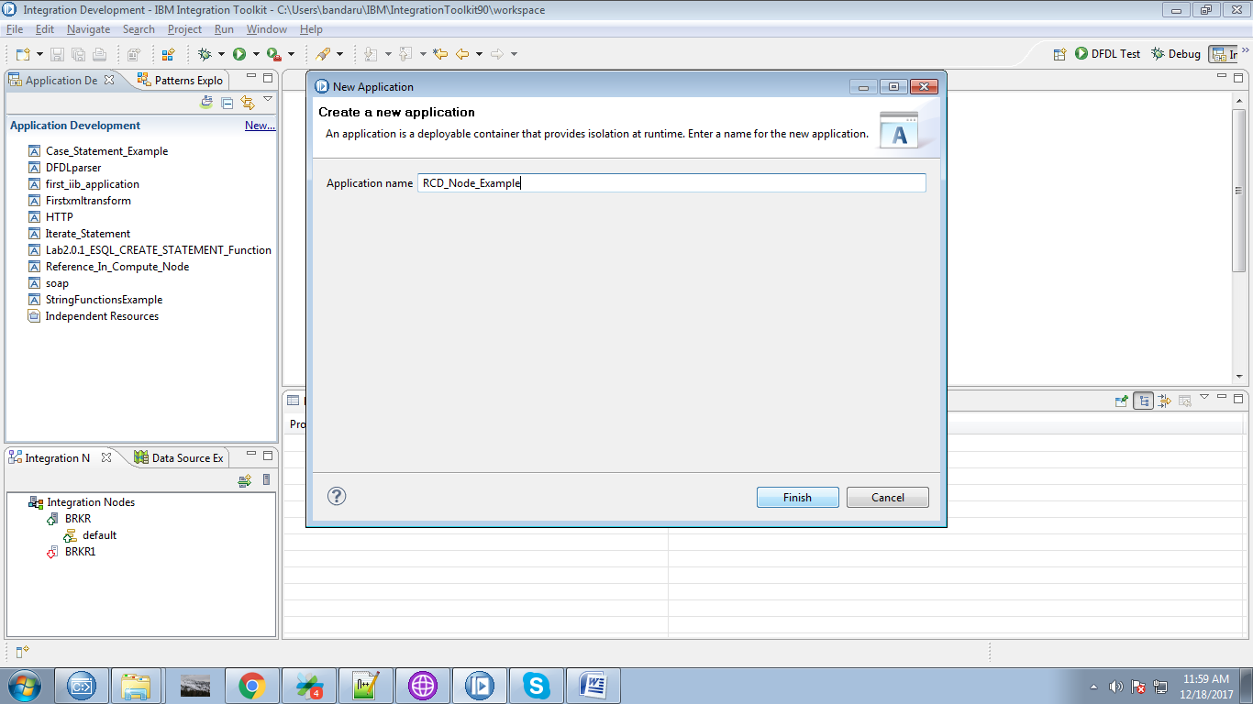

3. Under your application you able to see "New" click on it.

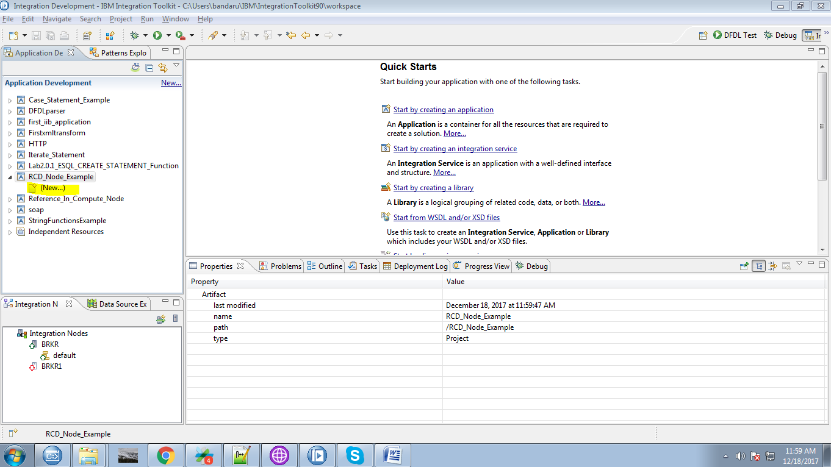

4. Select "Message Flow" from the given options.

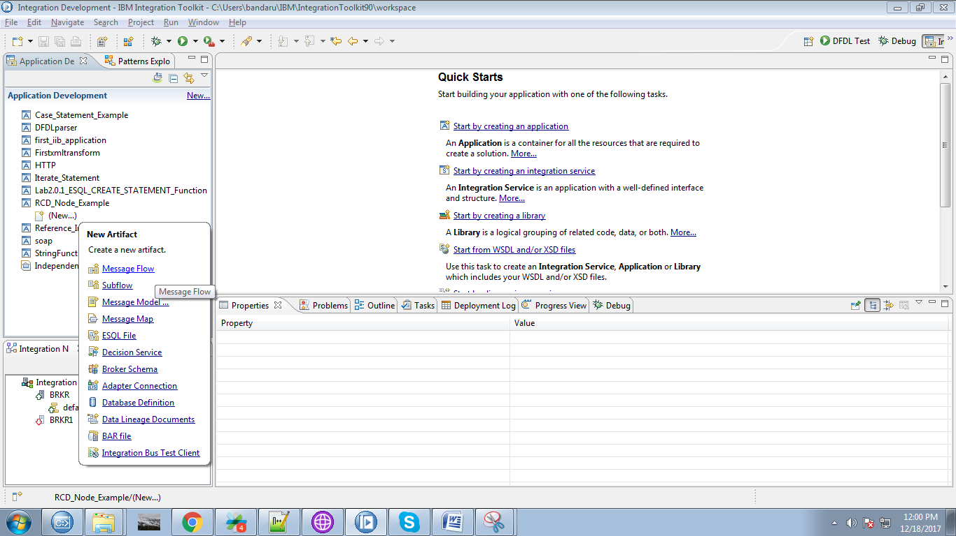

5. Name your flow and click "Finish" button.

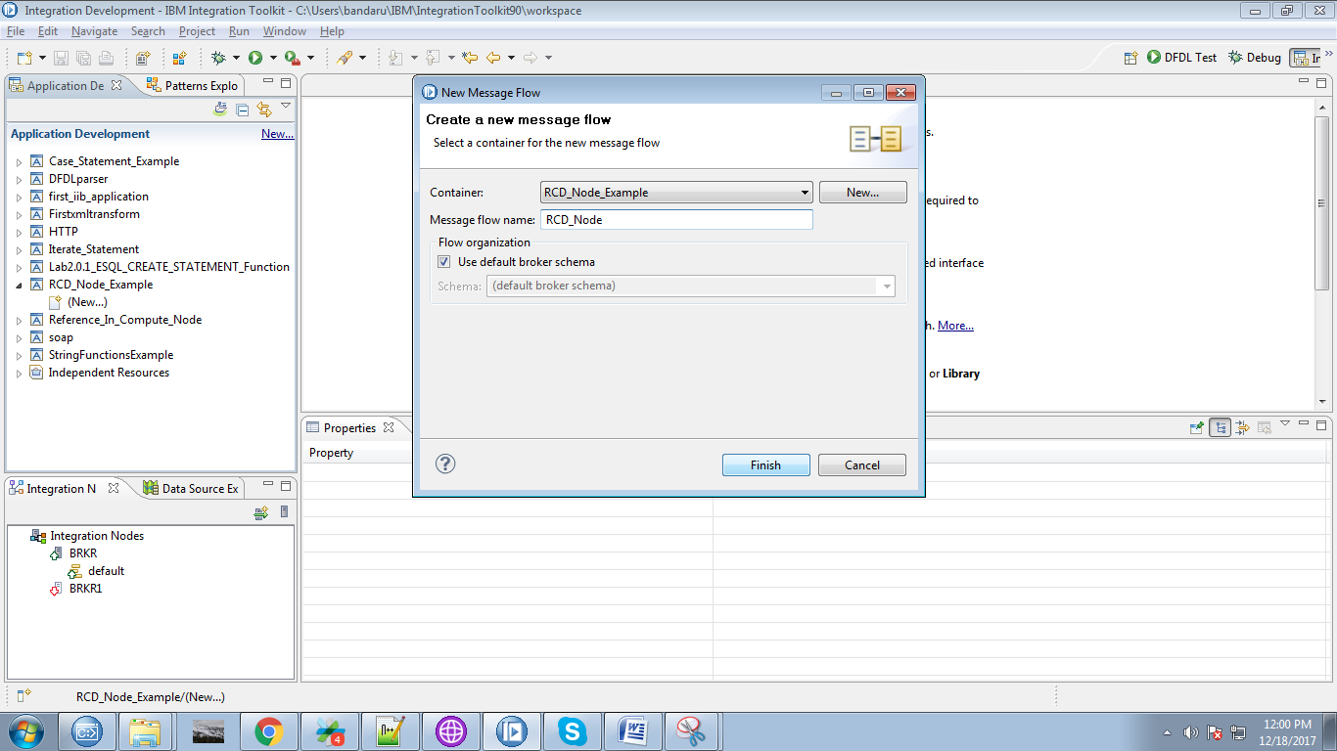

6. Drag the "MQInput" from the "WebSphere MQ" section and give a name for it.

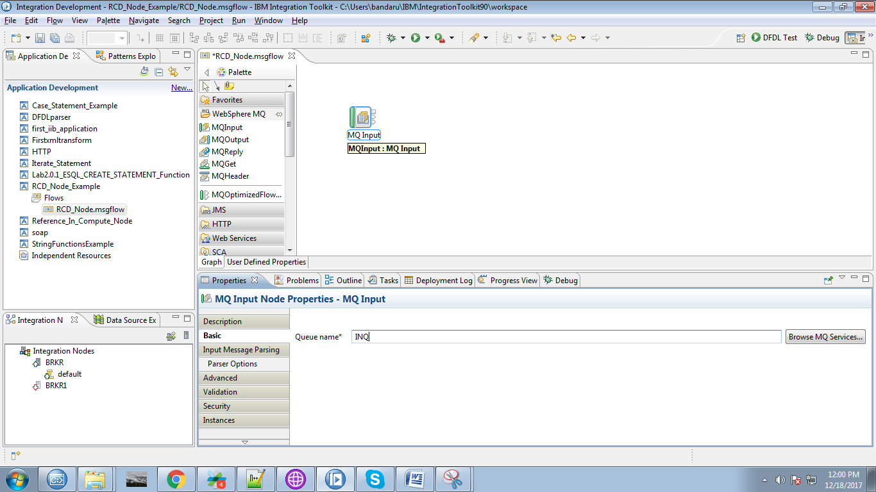

7. Drag the "RCD" node from the Construction section as shown below fig.

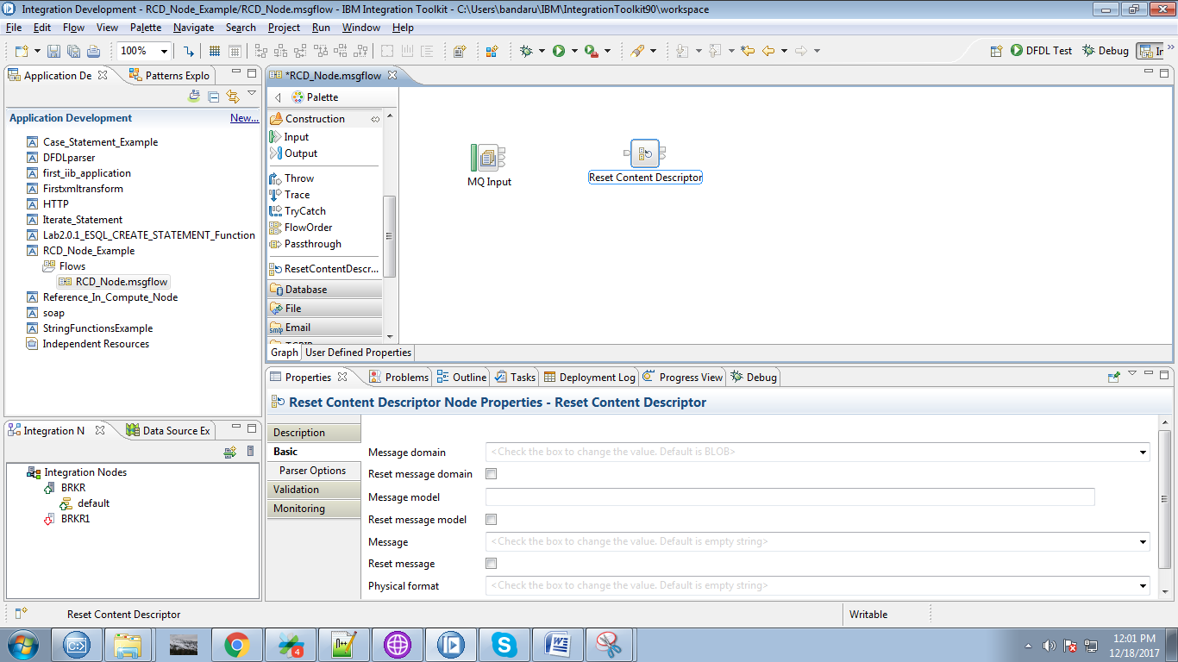

8. Connect the "output" terminal of the input queue to the "input" terminal of the RCD node as shown below.

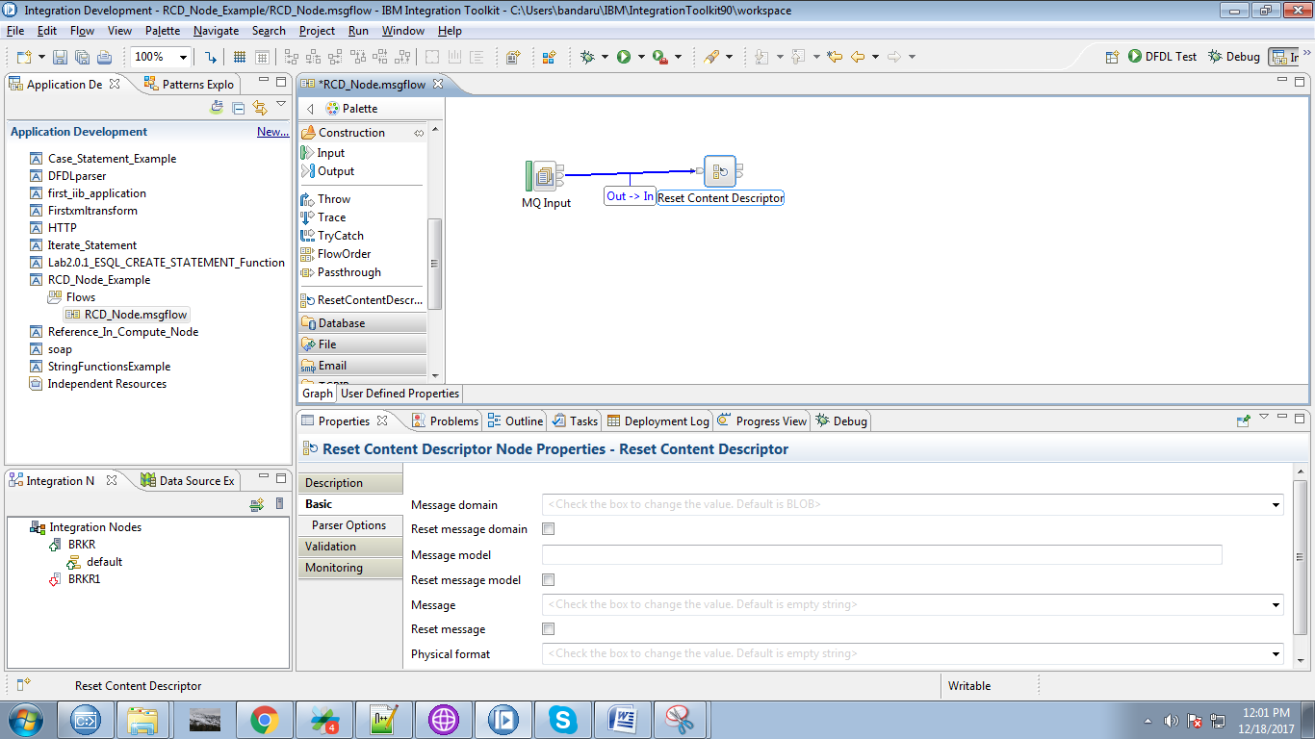

9. Select following two properties from the RCD node.

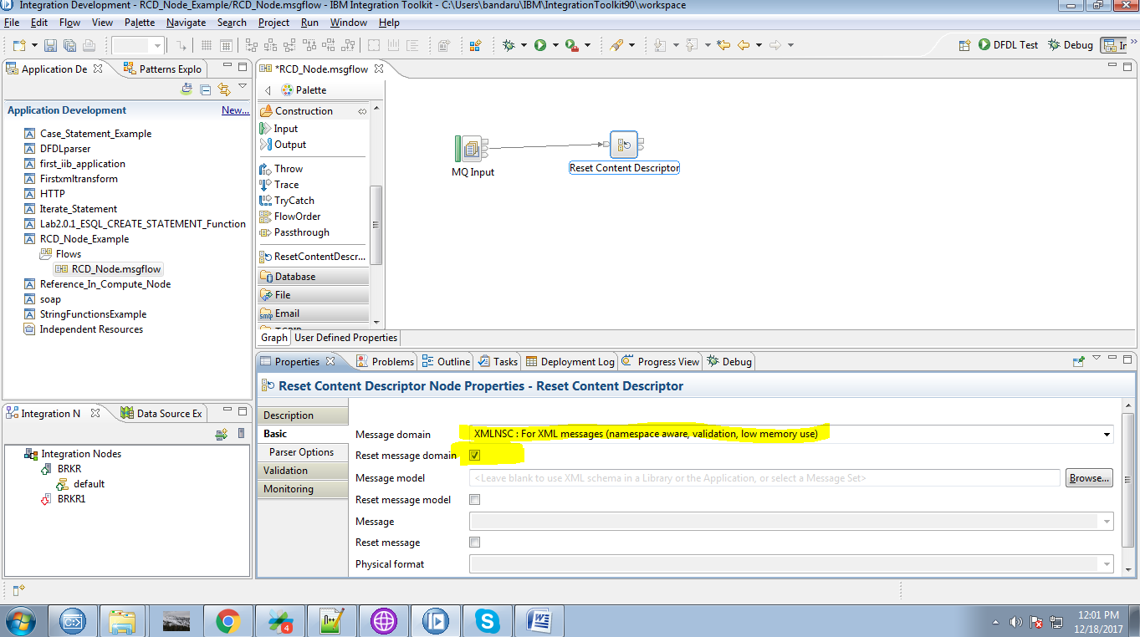

10. Drag the "MQOutput" from the "WebSphere MQ" and give it a name.

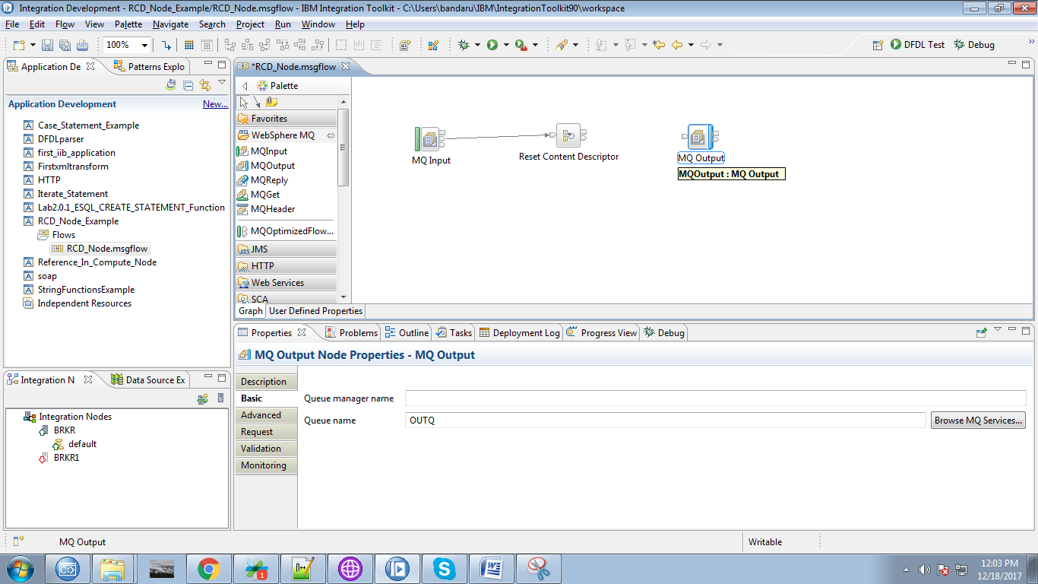

11. Connect the "output" terminal of the RCD node to the "input" terminal of the MQOutput.

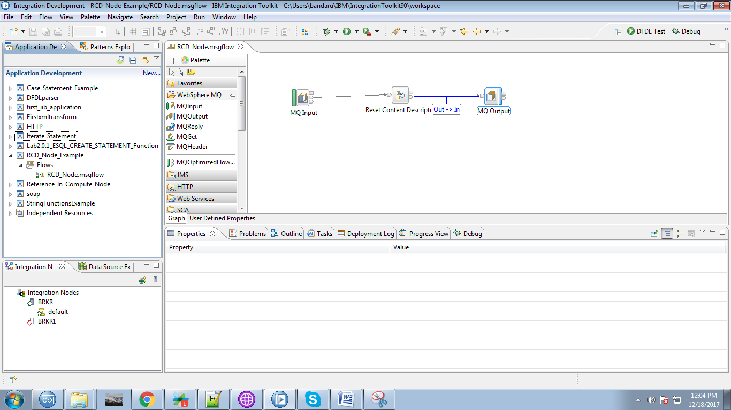

12. Here for MQInput we didn't selected any messaging domain.

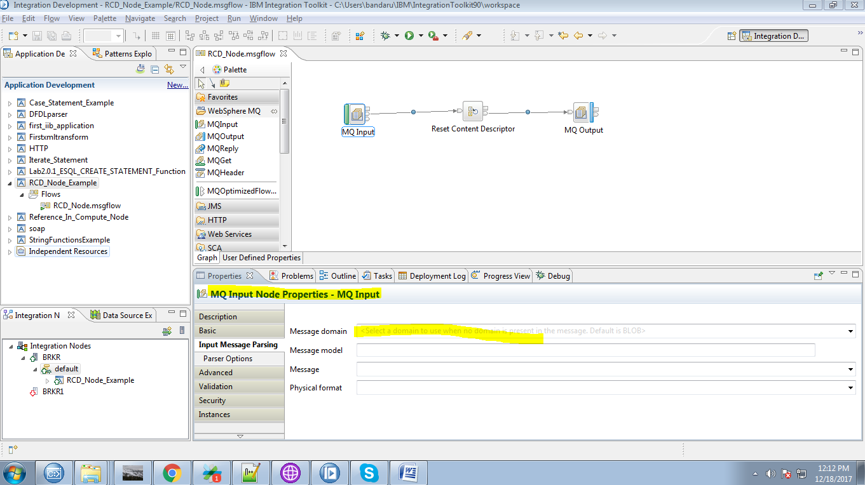

13. Right click on application you able to see "Deploy" option click on it.

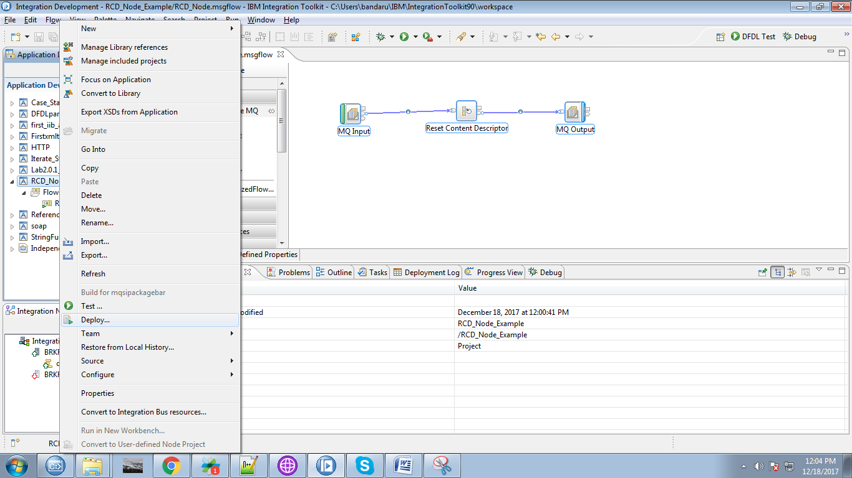

14. Select your runnung broker and execution group and click "Finish" button.

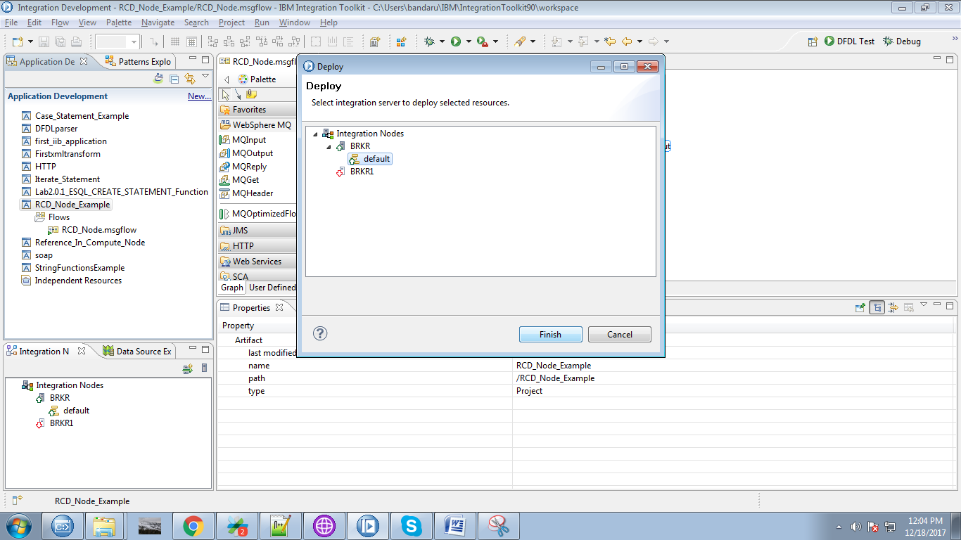

15. Create appropriate queues in "WebSphere Explorer".

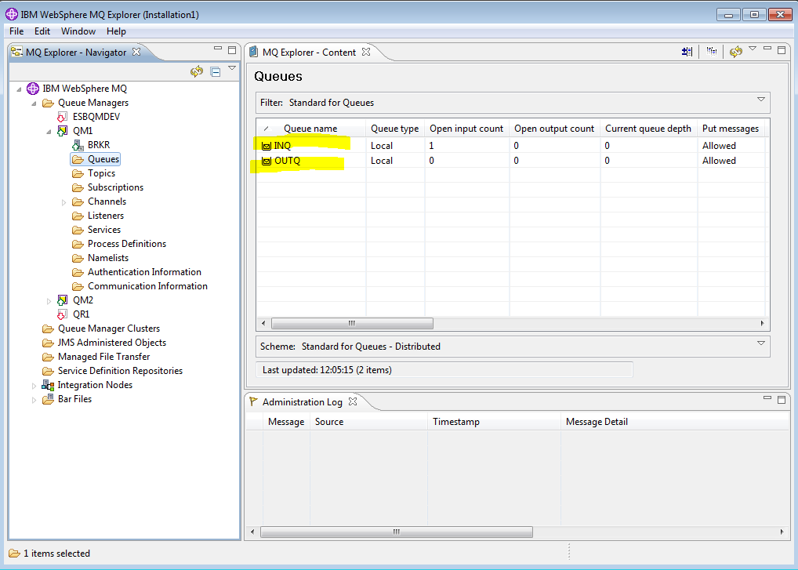

16. Open "rfhutil" and select your input queue.

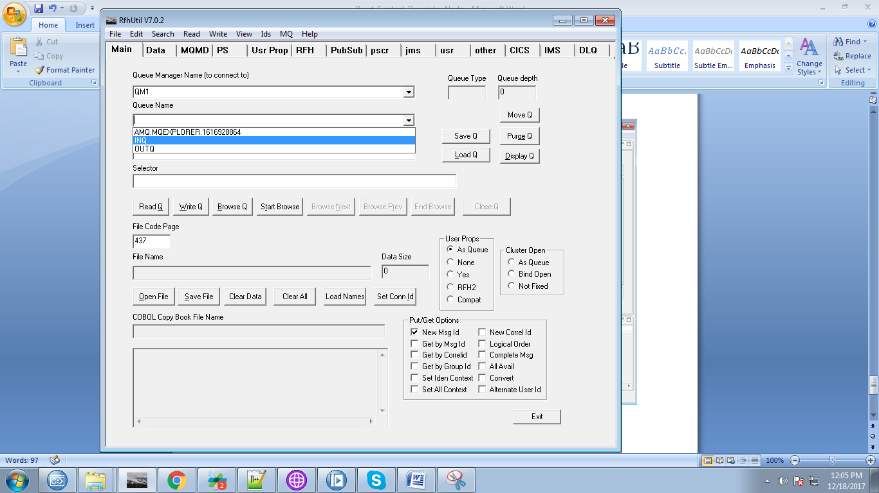

17. Click on "Open File" and select your input file.

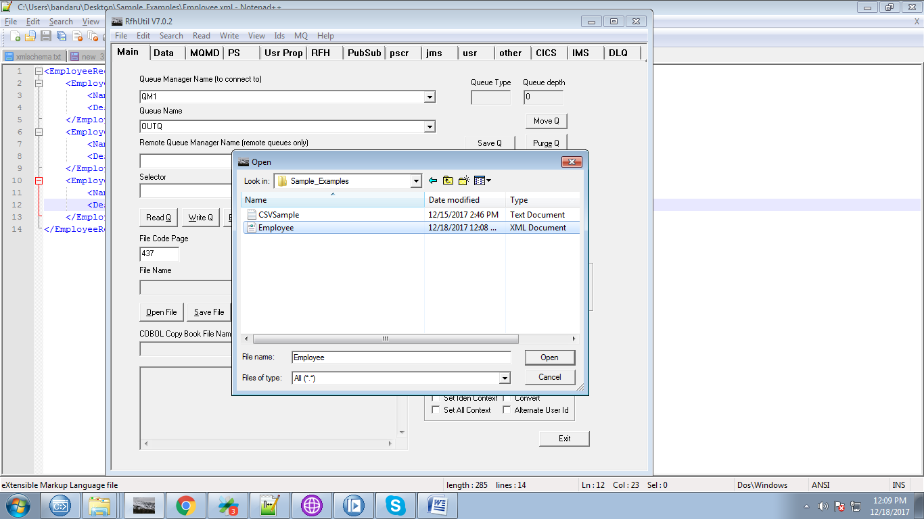

18. Our sample file consists of following data.

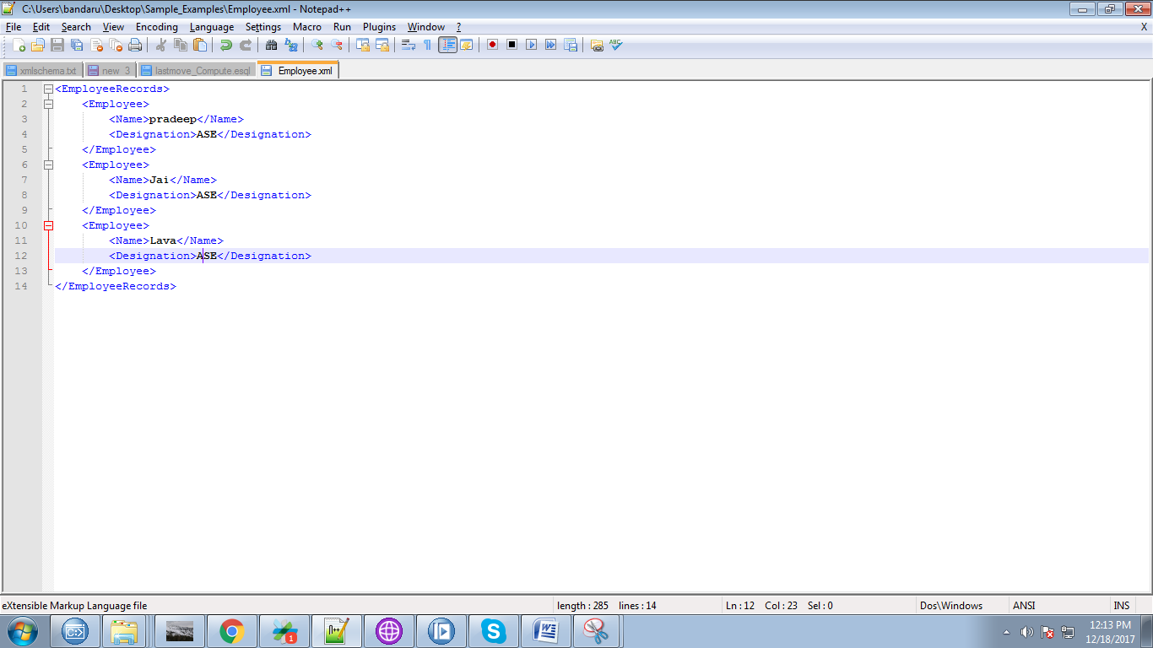

18. Now hit "Write Q" to trigger your flow.

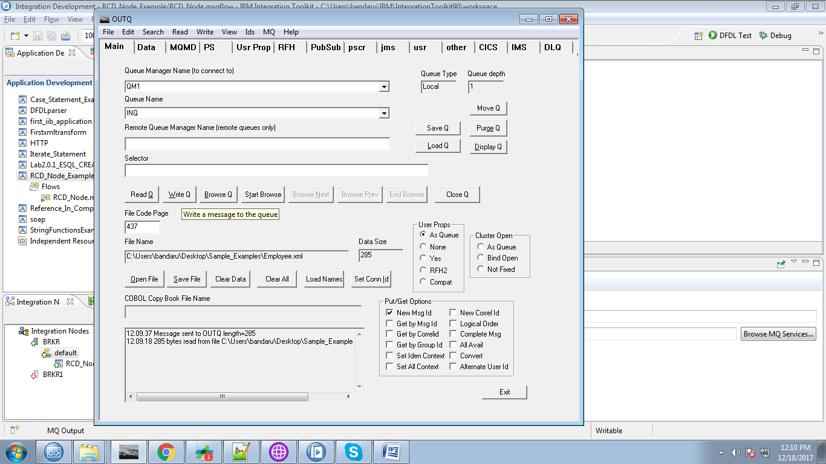

19. While your Flow in debug mode you can see data from the MQInput was in BLOB.

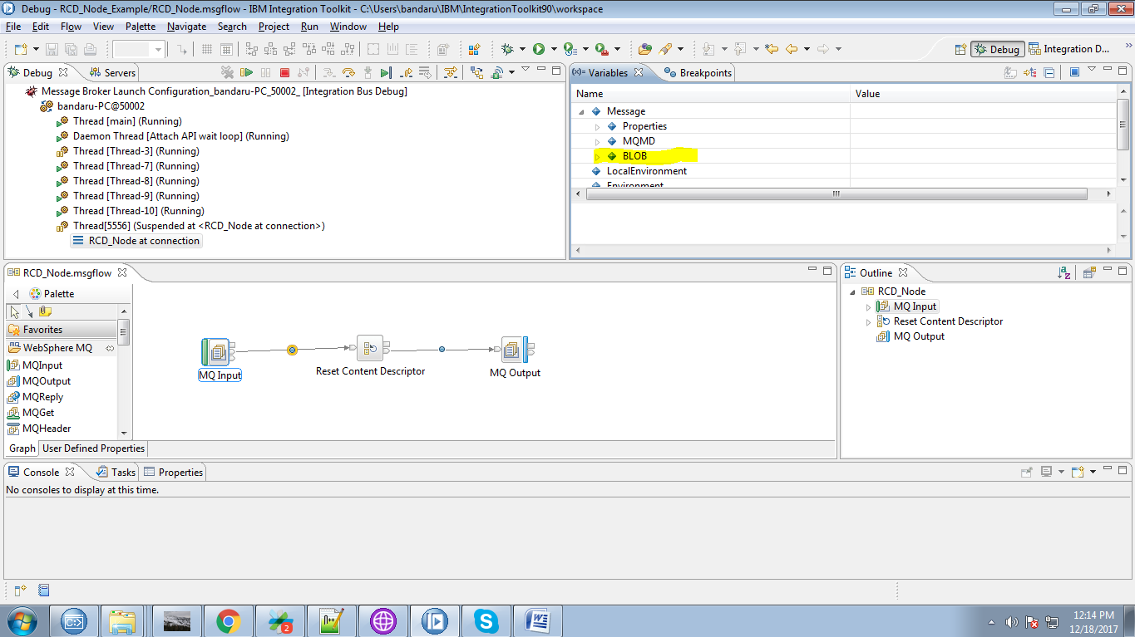

20. Data from the RCD node was in XMLNSC

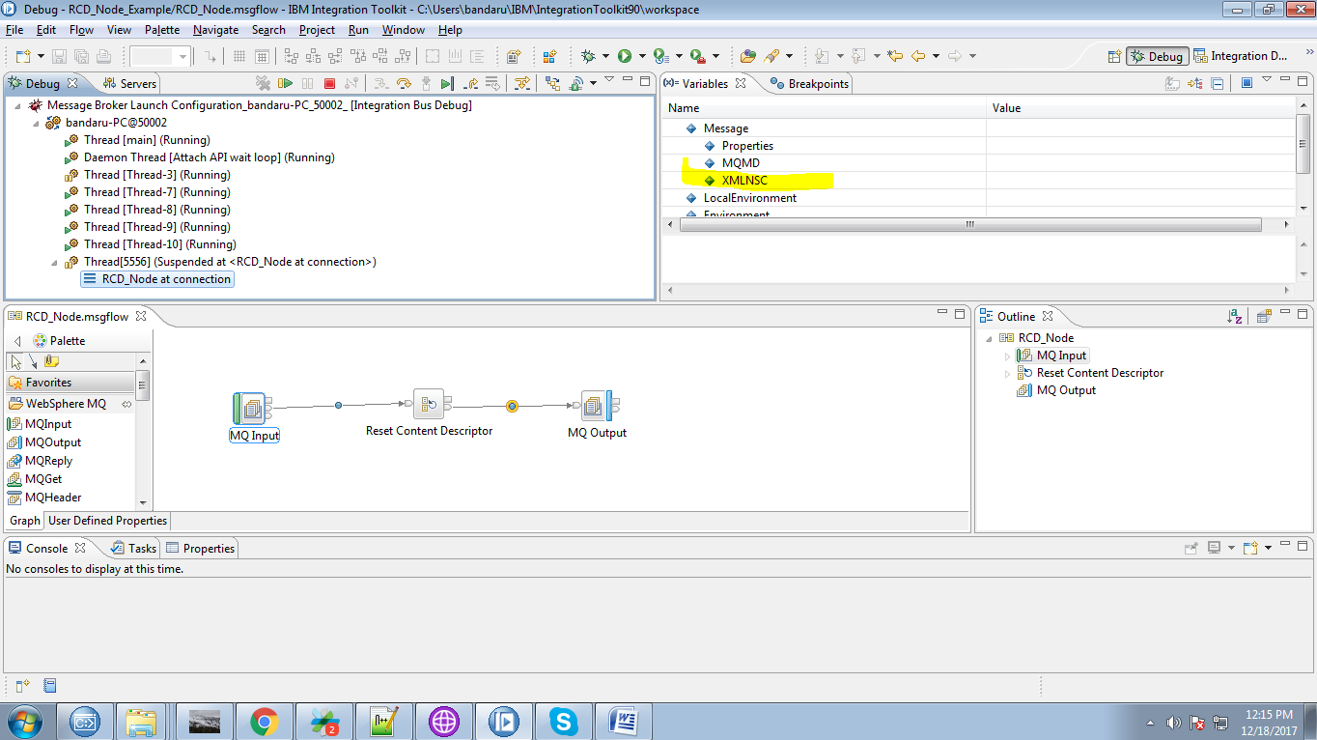

21. Now select output queue from the "rfhutil".

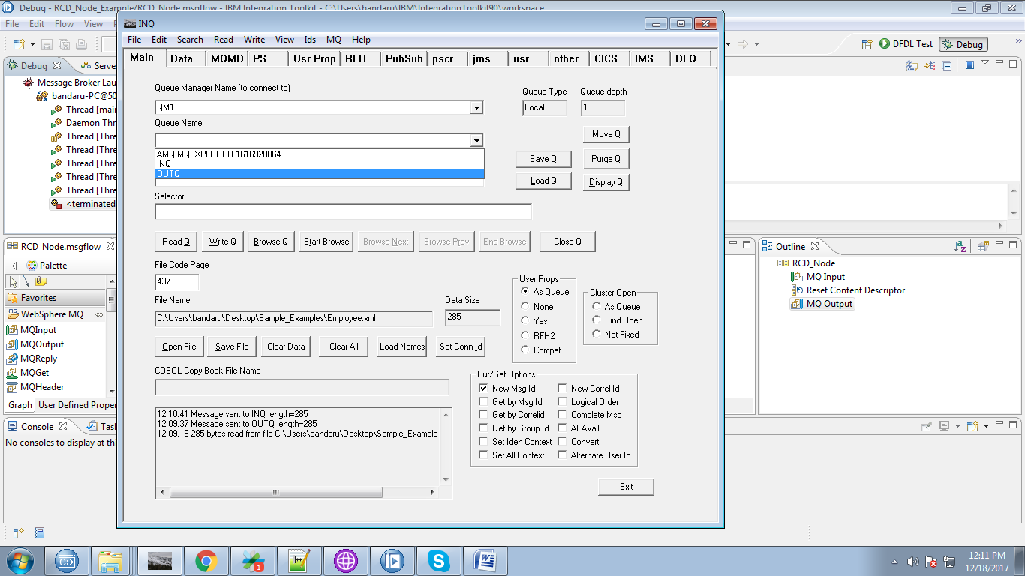

22. After selecting output queue, click on "Browse Q".

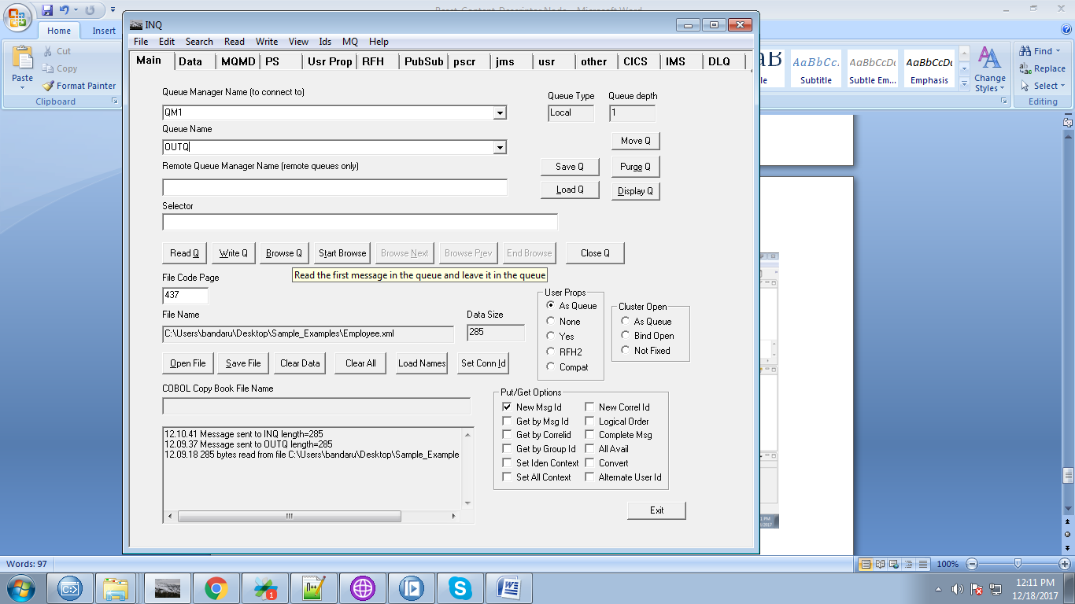

23. You can see your output in "Data" tab of "rfhutil".

